HOW TO FIND GRADIENTS OF PERPENDICULAR STRAIGHT LINES?
In the coordinate plane, two lines are perpendicular if the product of their gradients (m) is –1.
$$m_{1}×m_{2}=-1$$
Or $m_{2}=\frac{-1}{m_{1}}$
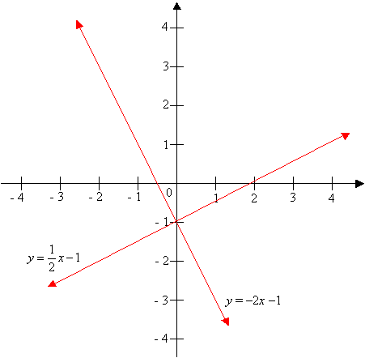
For example: The line y = ½ x - 1 is perpendicular to the line y = –2x – 1. The product of the two slopes is ½ × (-2) = -1.
Example: Find the gradient of the straight line that is perpendicular to the line $y=2x-3$.
Solution: Using $m_{2}=\frac{-1}{m_{1}}$
$m_{2}=\frac{-1}{2}$
Example: Find the gradient of the straight line that is perpendicular to the line $3x+2y=6$
Solution: Rewrite the equation $3x+2y=6$ in the form $y=mx+c$
$2y=-3x+6$
$y=\frac{-3}{2}x+3$
Hence: $m_{1}=\frac{-3}{2}$
Therefore: $m_{2}=\frac{-1}{\frac{-3}{2}}=\frac{2}{3}$
EXERCISE 5
- Find the gradient of a straight line perpendicular to $y=-3x-10$.
- Find the gradient of a straight line perpendicular to $2y-3x=6.$

